New Dashboard 2025-12-11 00:01:57
Search data, notebooks, recents, and more... CTRL + P workspace R
Product_Name: Long Grain Rice Reset all to defaultNew
Total Inventory Value Home
Workspace
Recents
Catalog
332.65K
Total Low Stock Count
455
Average Turnover Rate
50.15
Top 10 Products by Sales Monthly Inventory Value Trend Jobs & Pipelines
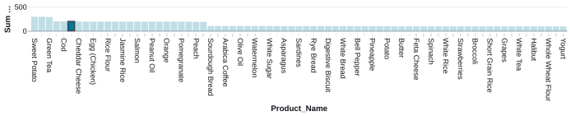
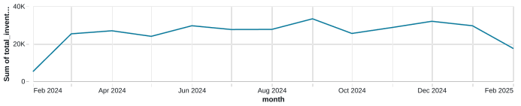
Compute
Marketplace
SQL
SQL Editor
Queries
Dashboards
Genie
TABLE: Low Stock Alerts
Alerts
Product_Name Catagory Stock_Quantity Reorder_Level shortage_amount Query History
Heavy Cream Dairy 14 99 85 SQL Warehouses
Cabbage Fruits & Vegetables 12 95 83
Data Engineering
Cucumber Fruits & Vegetables 12 93 81
Job Runs
Egg (Turkey) Dairy 19 100 81 Data Ingestion
Haddock Seafood 19 99 80
AI/ML
Evaporated Milk Dairy 23 100 77
Playground
Haddock Seafood 11 87 76
Experiments
Avocado Oil Oils & Fats 10 86 76 1 2 3 4 5 19
Inventory Value by Category (%)
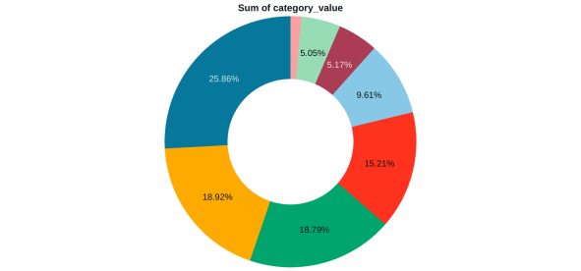
Catagory
Fruits & Vegetables
Beverages
Seafood
Dairy
Grains & Pulses
Oils & Fats
Bakery
null
Features Models Serving
•••

